Activity No. 2.1
Data Types and Arithmetic Operations
Course Code: CPE010 | Program: Computer Engineering
Course Title: Data Structures and Algorithms | Date Performed:08/07/2025
Section: CPE11S1 | Date Submitted:08/07/2025
Name(s): James Daniel M. Verano | Instructor: Engr. Jimlord M. Quejado
6. Output
- No Value output in seven cout attribute, and a comma between the cout attribute and arrows in eight cout attribute. And missing included extension for float precision.

#include<iostream>
using namespace std;
int main()
{
cout<<"The value of seven is: ";
cout<<"The value of eight and a half is: ", <<8.5;
return 0;
}
Improvised fixed code:

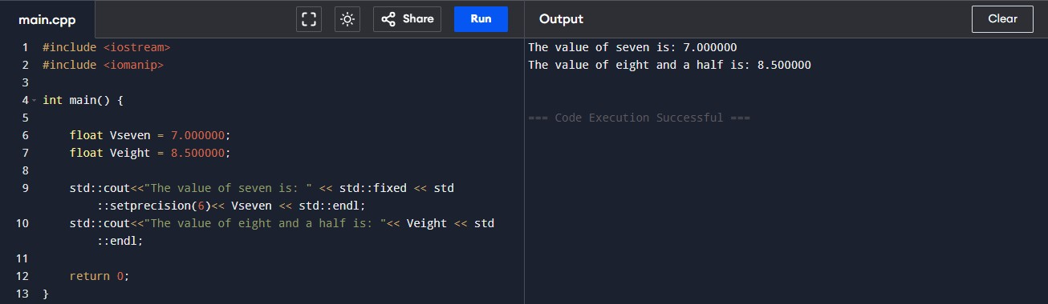

- Missing period between the seven decimal point, leading into an error, and missing included extension for float precision.

#include <iostream>
using namespace std;
int main()
{
cout<<"The value of seven is: "<< 7 0;
cout<<"The value of eight and a half is: "<<8.5;
return 0;
}

Improvised fixed code:

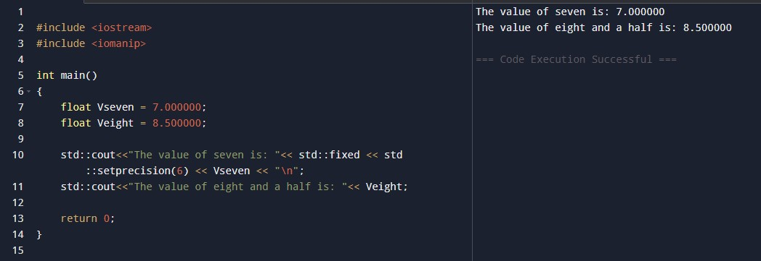

- Float values are inaccurate, missing included extension forv iostream, decimal setprecision and namespace std for Cout attributes; has unnecessary underscores and spaces.

int main()
{
float halfValue = 0.6;
float piValue = 3.141 592 65;
std::cout<<"The value of half is: "<< half Value;
std::cout<<"The value of Pi is: "<<pi_Value;
return 0;
}
Improvised fixed code:

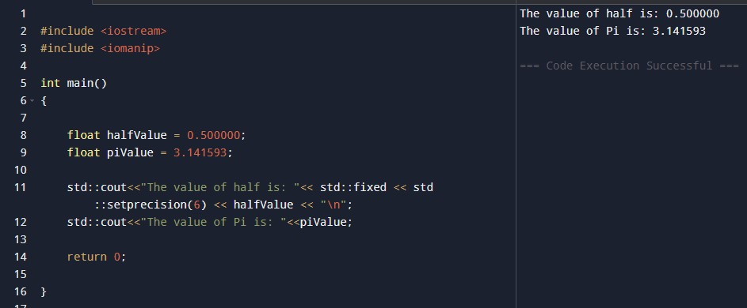

- Cin attribute is outputting the inter2 value other than receiving, no std namespace extenstion for cout attributes, and using the wrong version of apostrophe.

#include <iostream>
int main()
{
int integer1, integer2, sum; /*declaration */
std::cout<<“Enter first integer: \n” ; /* prompt */
std::cin>>integer1 ; /* read an integer */
std::cout<<“Enter second integer: \n” ; /* prompt */
std::cin<<integer2; /* read an integer */
sum = integer1 + integer2; /* assignment of sum */
std::cout<<“Sum is : "<<sum; /* print sum */

return 0; /* indicate that program ended successfully */
}
Improvised fixed code:

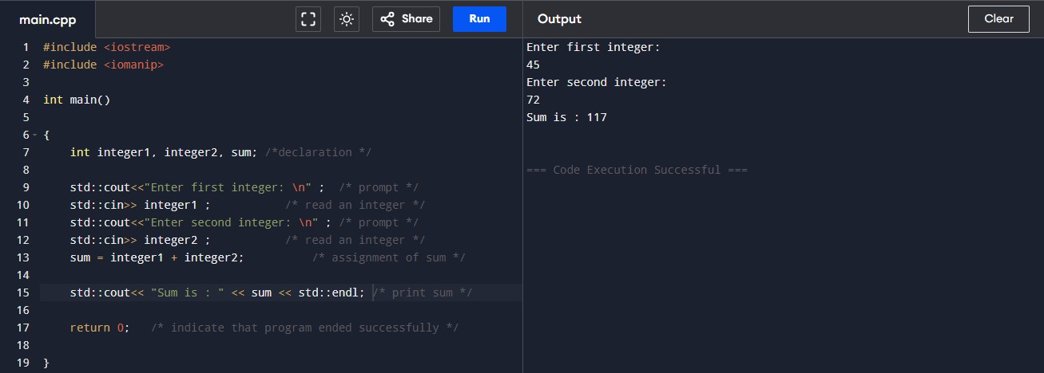
7. Supplementary Activity
- Take a look at the code below: it assigns two integer values, manipulates them and finally outputs the result and bigresult variables. The problem is that the manipulations have been described using natural language, so the code is completely useless now. Act as an intelligent (naturally!) compiler and translate the formula into a real "C" code notation. Test your code using the data provided.

#include <iostream>
using namespace std;
int main(void)
{
int xValue=5;
int yValue=9;
int result;
int bigResult;
/*
increment xValue by 3
decrement yValue by xValue
multiply xValue times yValue giving result
increment result by result
decrement result by 1
assign result modulo result to yValue
increment result by result added to xValue
assign result times result times result to bigResult increment result by xValue times yValue
*/

cout<<"result: "<<result;
cout<<"big result: "<< bigResult;
return 0;

Interpreted C code notation:

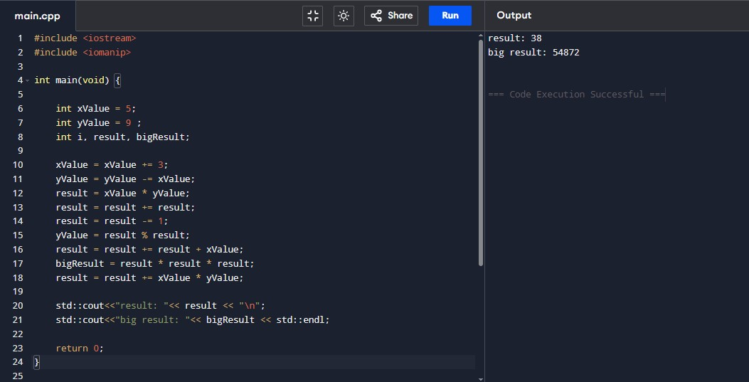

- Complete the program below. Compute the accrued amount of money with a starting value of 100 and an annual interest rate of 1.5%. Compute and print the results for first three years. Your version of the program must print the same result as the expected output for every year. Compute each annual value on the basis of the previous year's value.

#include <iostream>
using namespace std;
int main()
{
float startValue = 100;
float interestRate = 0.015;
float firstYearValue;
float secondYearValue;
float thirdYearValue;

/* Your code */

cout<<"After first year: "<<firstYearValue;
cout<<"After second year: "<<secondYearValue; cout<<"After third year: "<<thirdYearValue;
return 0;
}

Interpreted C code notation:

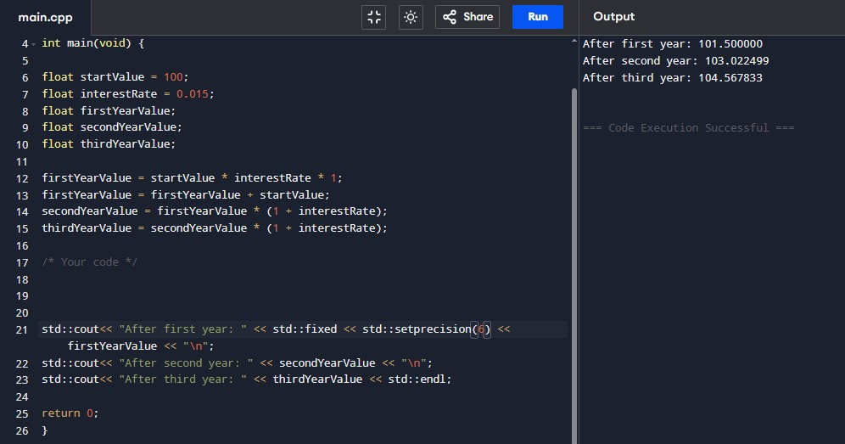
8. Conclusion
- I have learned and was able to pinpoint the errors in the source code given in the examples, and I was able to interpret the activity 1 and 2 to create a functionable code that results to the exact expected result. I have learned too that extensions are also needed to include decimal precision points and etc.
9. Assessment Rubric

